**TOTAL FRAMES IN THE STOCK MANAGEMENT SYSTEM**

Overall , the project "**Stock Management System**" , will have following frames:

1. **SplashScreenFrame**
2. **LoginFrame**
3. **ManagerOptionsFrame**
   1. **ManageEmplyeesFrame**
      1. **AddEmployeesFrame**
      2. **UpdateEmployeesFrame**
      3. **RemoveEmployeesFrame**
      4. **ViewEmployeesFrame**
   2. **ManageReceptionistFrame**
      1. **AddReceptionistFrame**
      2. **UpdateReceptionistFrame**
      3. **RemoveReceptionistFrame**
      4. **ViewReceptionistFrame**
   3. **ManageStocksFrame**
      1. **AddStocksFrame**
      2. **UpdateStocksFrame**
      3. **DeleteStocksFrame**
      4. **ViewStocksFrame**
   4. **ViewOrdersFrame**
4. **ReceptionistOptionsFrame**
   1. **BillingFrame**
   2. **ViewOrdersFrame**

**COMMON SCREENS**

**============================================================================================**

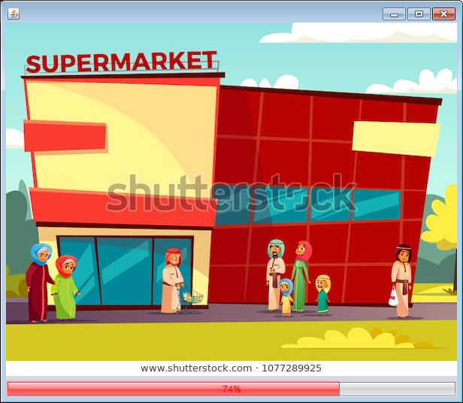

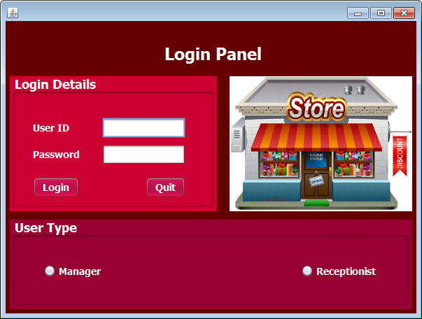

**ADMIN SCREENS**

**============================================================================================**

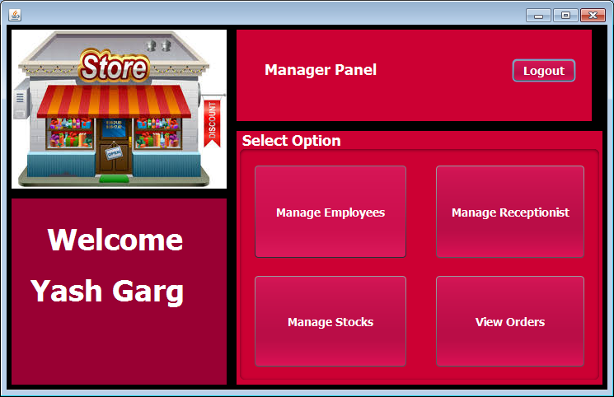

1. MANAGE EMPLOYEES

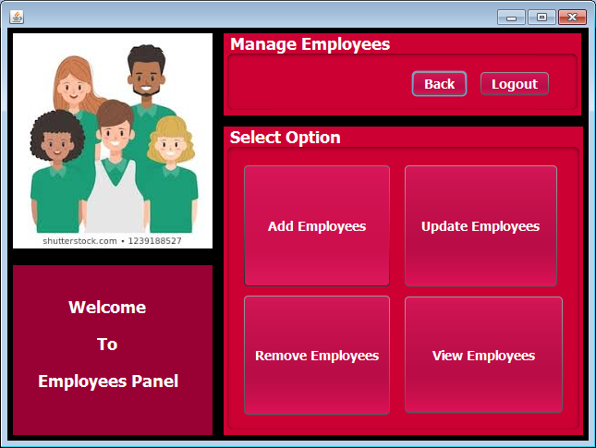

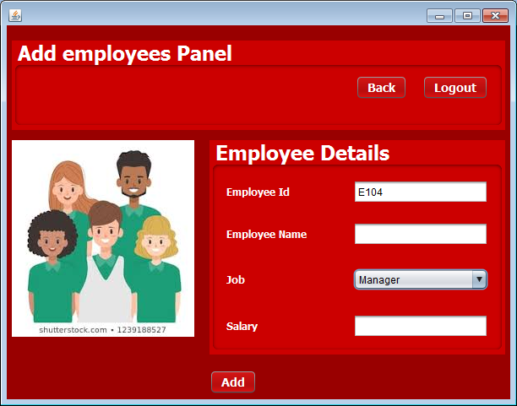

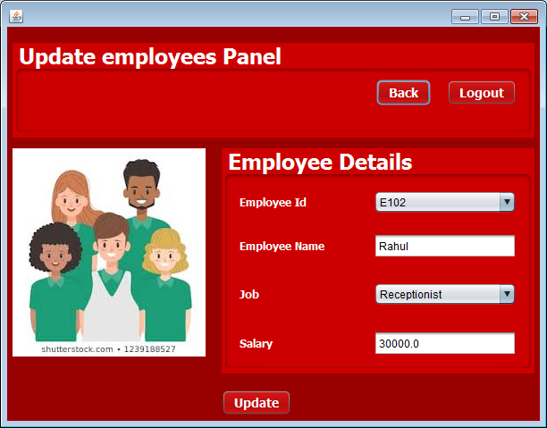

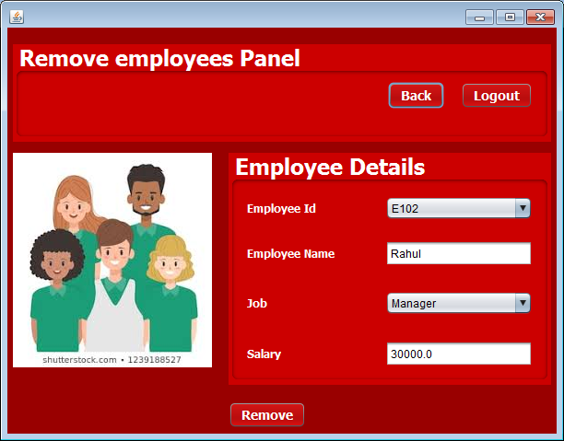

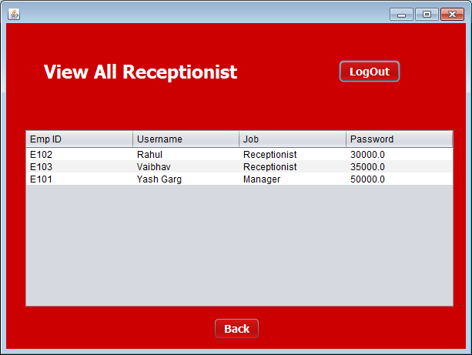

1. MANAGE RECEPTIONIST

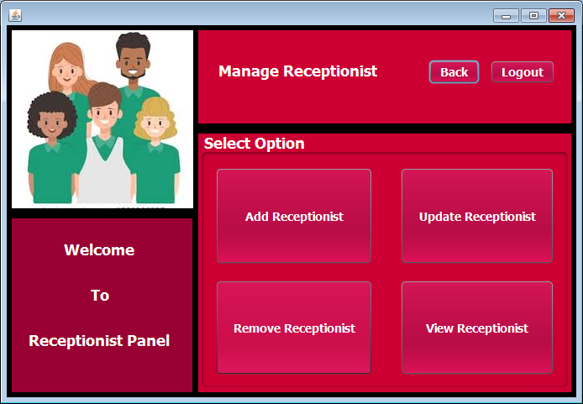

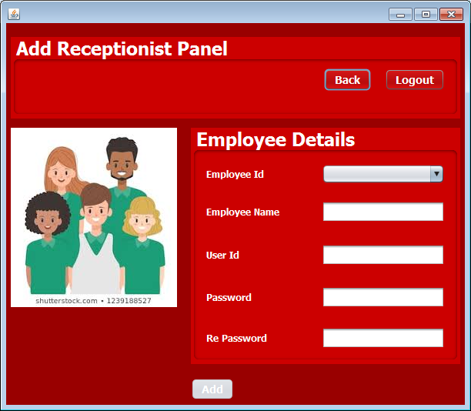

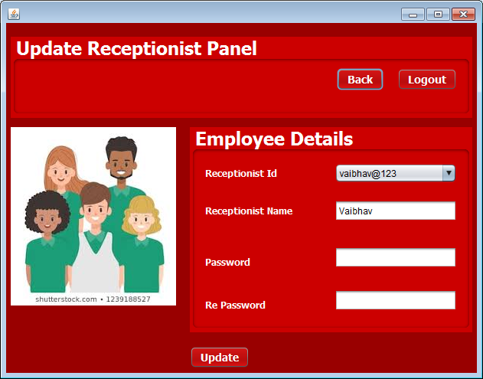

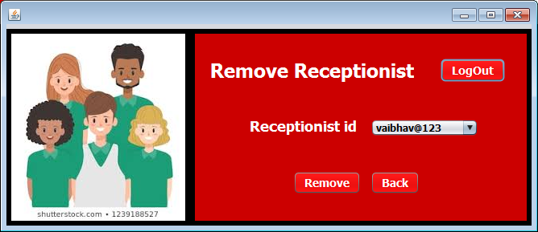

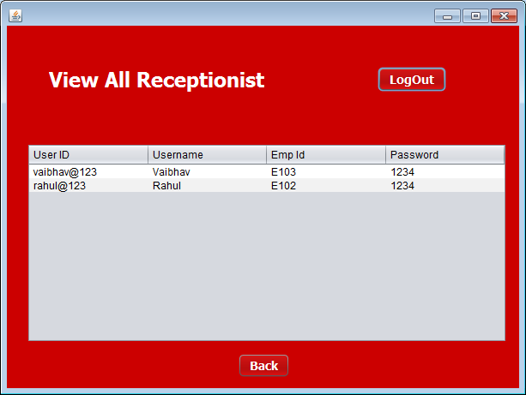

1. MANAGE STOCKS

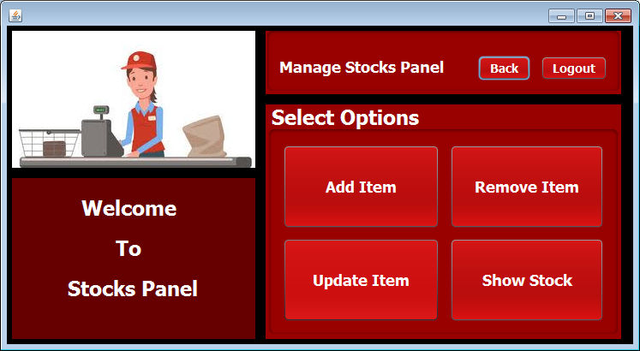

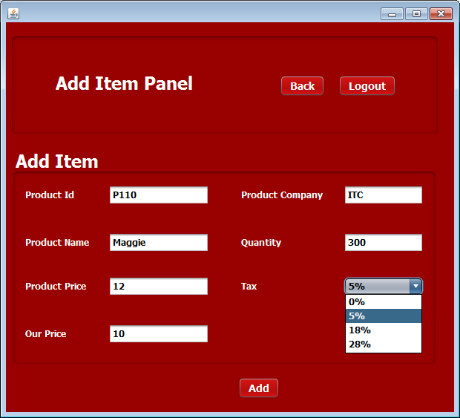

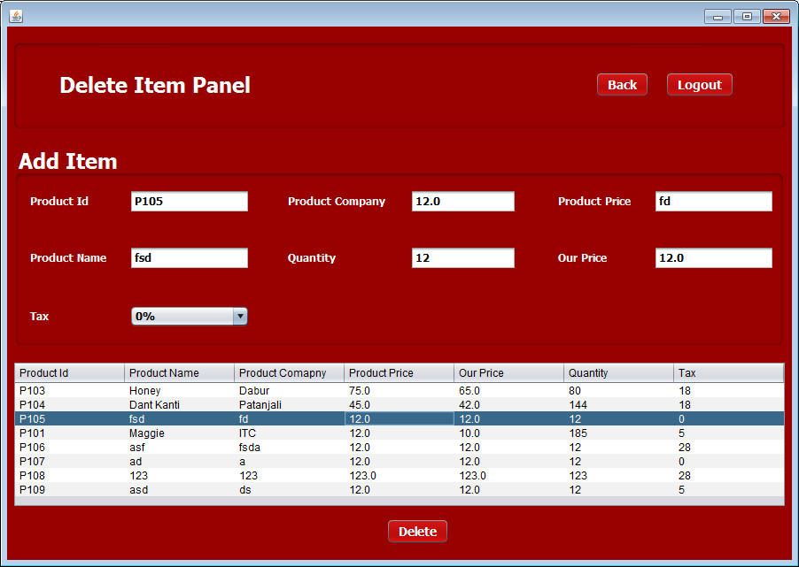

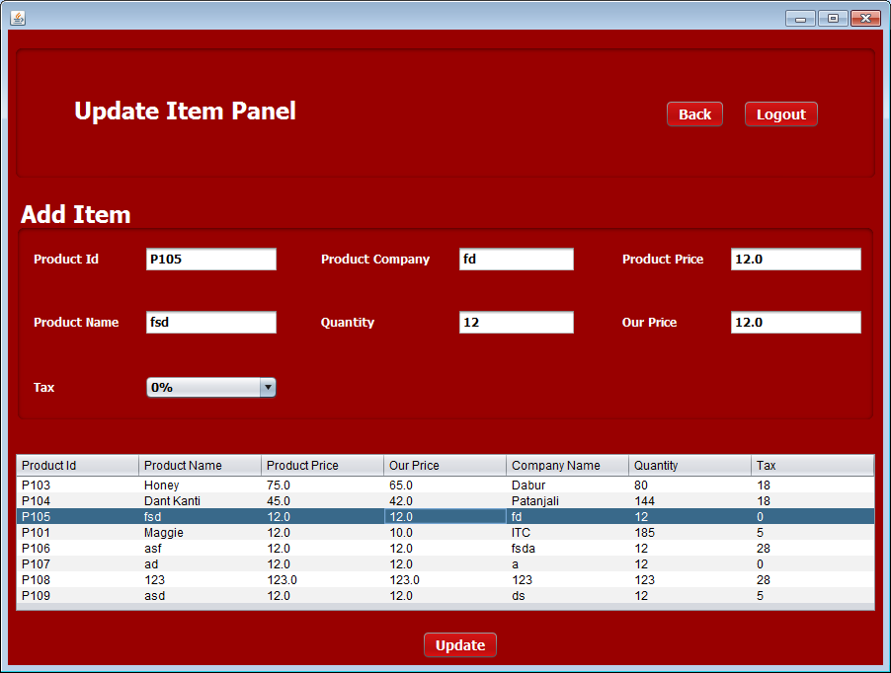

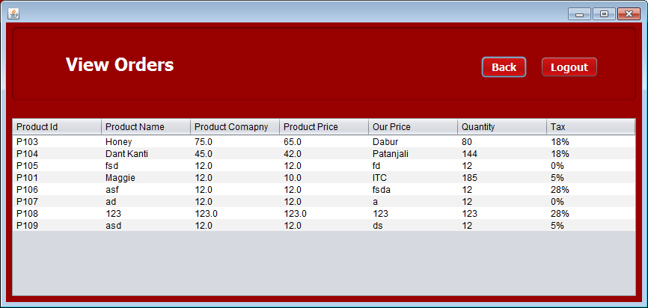

1. VIEW ORDERS

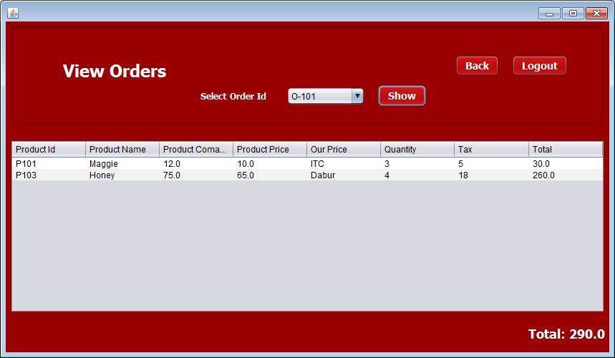

**RECEPTIONIST SCREENS**

**============================================================================================**

